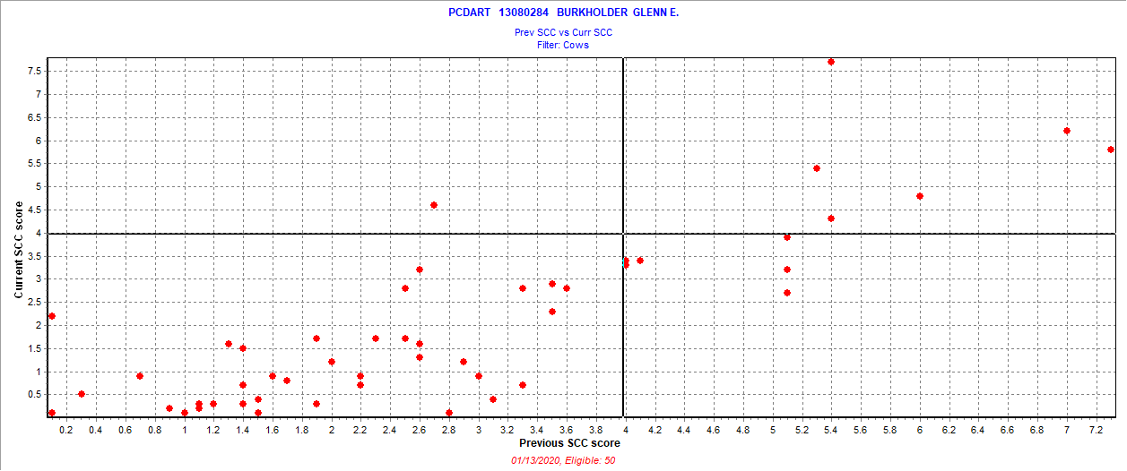

January 6 2020 test date

New = 1 = 2.0%

Chronic = 6 = 12%

Cure = 6 = 12%

Uninfected = 37 = 74.0%

Also 1 fresh cows SCC > 3.9